
Methods 11 Test 1 2018
Quadratic and Linear Functions
Total Marks: 59 Time Allowed: 60 minutes
Name: _______________________

Resource Free
ALL working must be shown for full marks.

1. [4, 4, 3, 3 = 14 marks]

Solve the following:

a) $\frac{4}{4-x}= \frac{4}{x+2}+1$ b) $x^{2}+4x-3=0$

c) $6x^{2}-x-2=0$ d) solve by completing the square
$x^{2}+4x-6=0$

2. [2, 2, 2, 2 = 8 marks]

Find the discriminant of each quadratic equation and state the number of real roots it has.

a) $x^{2}-x-4=0$ b) $2x^{2 }+3x+6=0$

c) $x^{2 }+6x+9=0$ d) $-2x^{2}+8x-2=0$

3. [3, 2 = 5 marks]

The line with equation 7x + 5y = 70 intersects the x-axis and y-axis at A and B respectively.

a) Find the coordinates on the mid-point AB.

b) Find the distance between A and B. Leave answer in exact form.

4. [3, 2, 2 = 7 marks]

a) What is the equation of the line passing through the point (-5, 3) and is perpendicular to
2y = 10x – 6?

b) Write the equation of the line that passes through the point (-2, 4) and is parallel to the equation y = 3x + 2.

c) A line passes through the point with coordinates (1, 2) and has a gradient of 2. If it passes through the point with coordinates (5, k) find the value of k.

5. [6 marks]

In the triangle ABC, A has co-ordiantes (-6, -3) while B has co-ordinates (k, 5) and C has co-ordinates (8, 2). Find the value of k if angle ABC is a right angle.

6. [2, 2, 2 = 6 marks]

Define each of the following as a function, or a relation, giving a reason for your choice.

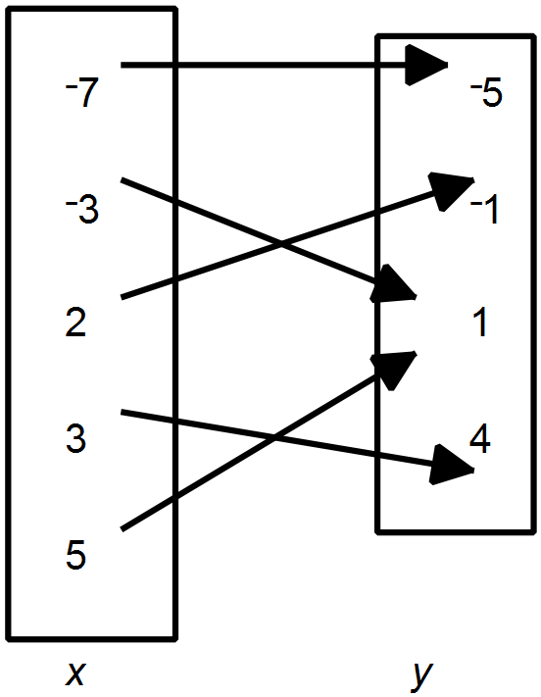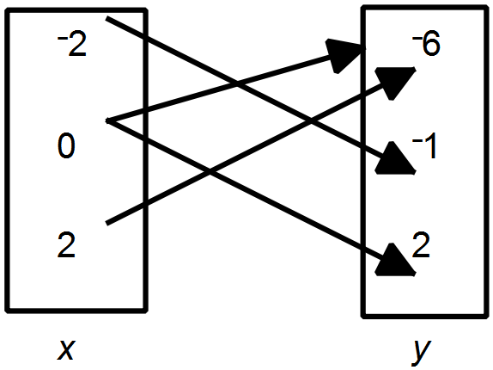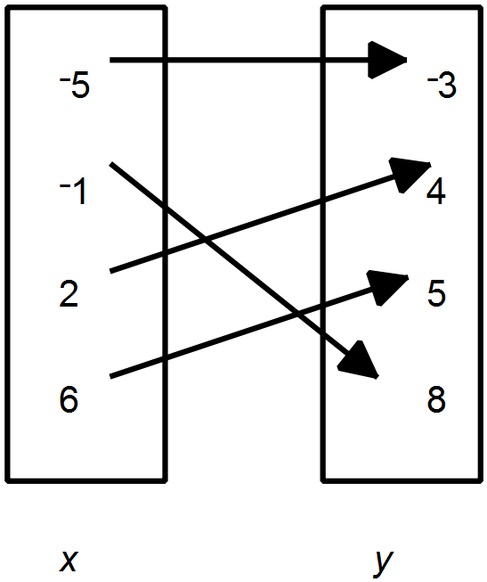 a) b) c)

7. [3, 5 = 8 marks]

Determine the equation for the following.

a)
x | 0 | 1 | 2 | 3 | 4 | 5
y | -2 | 7 | 24 | 49 | 82 | 123

b)
x | 2 | 3 | 4 | 5 | 6 | 7
y | 19 | 32 | 49 | 70 | 95 | 124

8. [1, 1, 1, 2 = 5 marks]

The value of a photocopier t years after purchase is given by V = 9000 – 900t dollars.

a) Find V when t = 4.

b) Find t when V is 3600.

c) Find the orginial purchase price of the photocopier.

d) For what values of t is it reasonable to use this function? Give an explanation.

